**Introduction:** This activity is inspired by Derby Museums’ collection of Joseph Wright paintings, which often use frames of darkness to highlight areas of light to draw in the gaze of the viewer. Learn how to frame a favourite scene of your own by making a view finder.

**You will need:**

* *For your view finder –* 
  + A4 card (you can use an old cereal box)
  + Ruler
  + Scissors
  + Fine string or dental floss and tape (optional)
* *For your drawing –* 
  + Tack or tape
  + Plain paper
  + Your chosen drawing materials





**To make your view finder:**

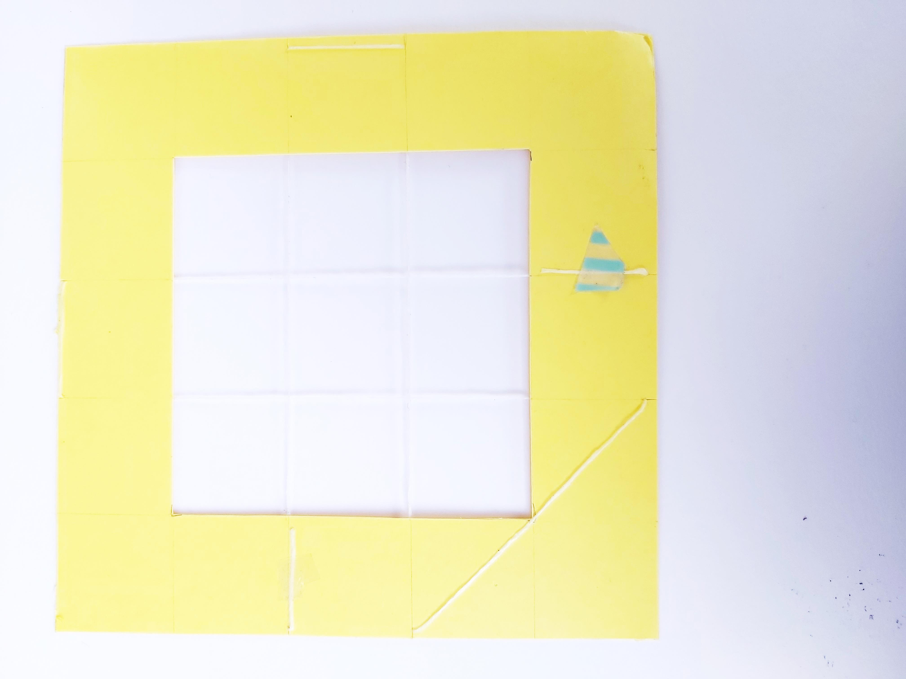

**Step 3 -** If you would like to create a grid to guide your drawing, cut small notches at regular intervals into each side of your card. The more notches you make the more lines on your grid. Our example has two notches 6cm and 9cm across. Thread fine string or floss across these gaps in a grid pattern and secure with tape.

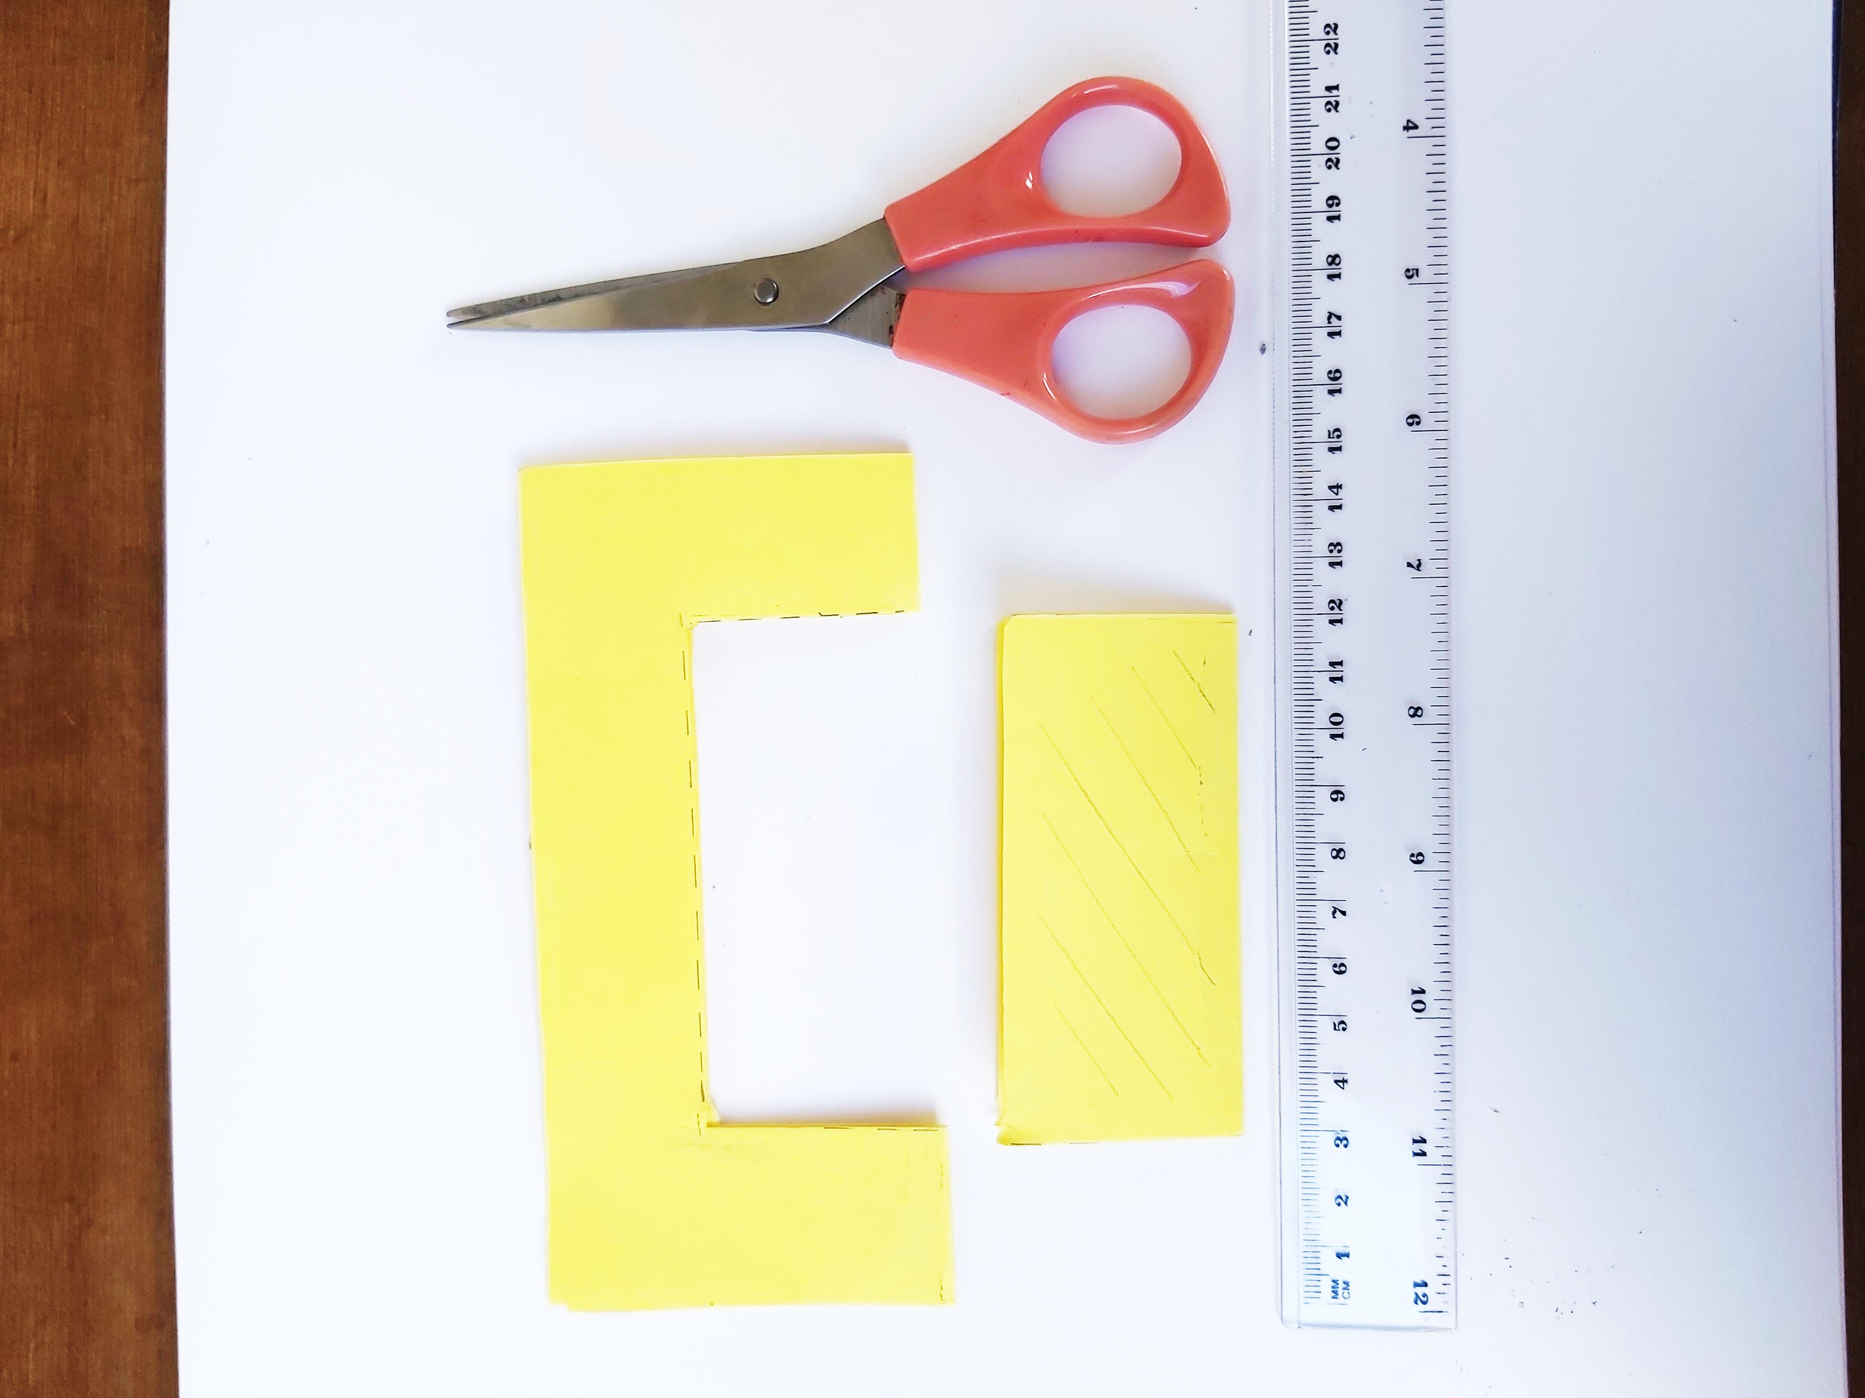

**Step 2 -** Measure and cut a square or rectangle into the centre of the card by folding the card in half. Our example is 9cm by 9cm.



**Step 1 -** Measure and cut your card down to a regular square or rectangle. Our example is 15cm by 15cm.

**Share your drawings with us using #DrawingforWellbeing**

**What to do:**

1. 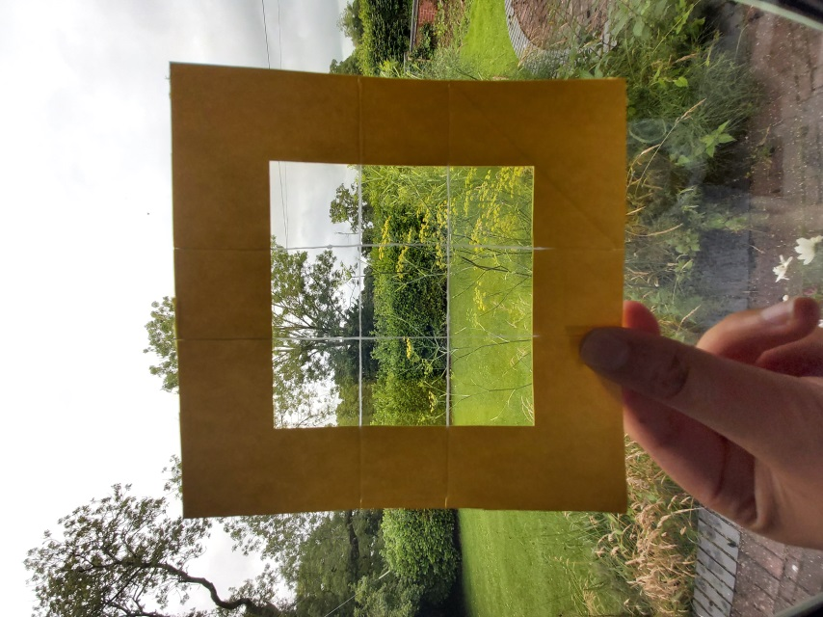Choose your favourite view (it doesn’t have to be dramatic or beautiful) and tape your view finder to the window.
2. Notice how moving away from the view finder will make everything smaller and going closer will give you a larger image, like a camera lens.
3. Take some time to look through the view finder. It’s easy to feel overwhelmed when you are deciding what to fit on the paper, so the view finder is a useful tool for isolating a view and helps to select what you want to put in your composition or picture.
4. Start by selecting a starting point - the centre of the page is good - marking out from there on the paper. There is no right or wrong way to do this, so have fun! Gradually build up the lines, look at different textures and shapes and, when you feel it’s finished, draw another view!

**Heidi’s tips:**

When you are ready to begin your drawing, relax by rolling your shoulders, shaking out your hands, fingers and arms. Take a deep breath, hold for five and breathe out. Repeat a few times and smile!

You can stand or sit but make sure you are comfortable and able to rest your sketch pad or drawing board in front of your view finder. You could also tape the paper to the windowpane.