Audience: Adults and young people.
This activity is great for: discovering new skills and techniques, being inspired by nature, and thinking about your wellbeing.
Introduction: This activity is inspired by the spectacular birds in our Nature gallery at Derby Museum & Art Gallery, where we encourage you to take time to notice nature and feel joy. In the spirit of this attitude, this session is designed for you to have a go, in your own time.
There may be some new ideas for you to try, but if not we hope it will encourage you to take time for yourself and enjoy some creative time. Try not to focus on creating the perfect drawing - this can be frustrating when working with images of animals as we know what they “should” look like – but instead try to enjoy the process of drawing.
You will need:
- Something to draw onto – paper, card or canvas
- Your choice of drawing materials – Stevie uses pencils, felt tip pens, watercolours and biros
- Photographs or pictures of birds, unless you are outside drawing them live!

Don’t forget to share your drawings using #DrawingforRelaxation

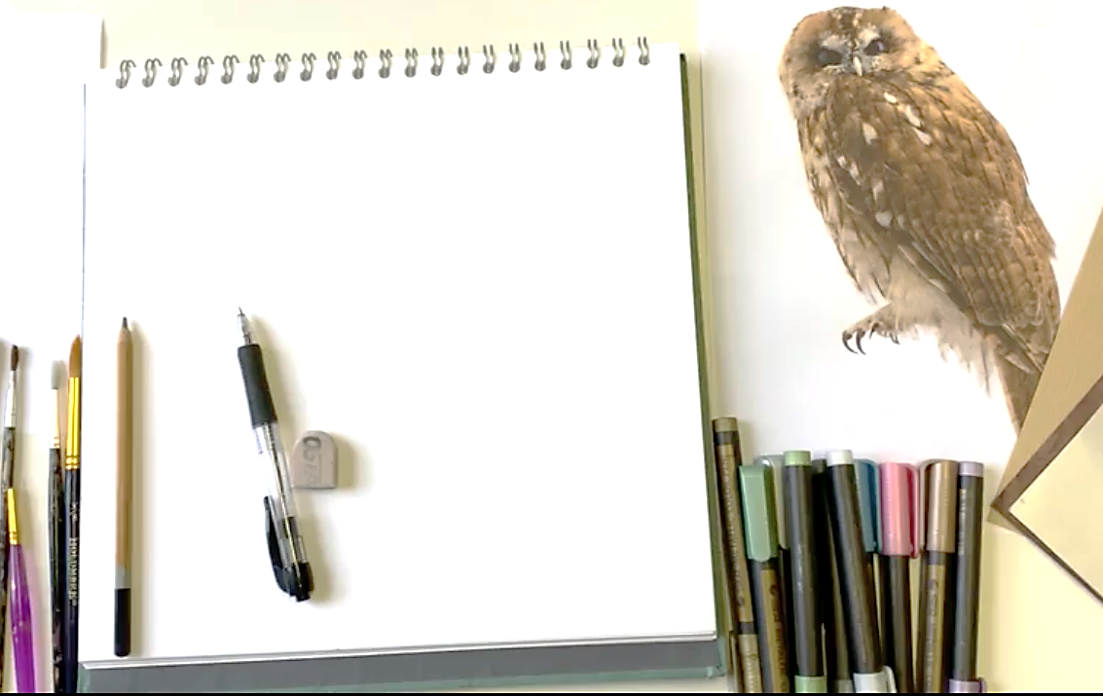

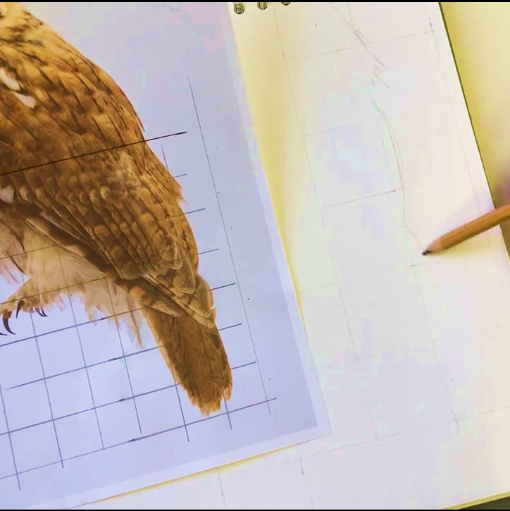
Stevie used the grid technique here, first marking out a series of 2cm squares onto her photo, and then drawing a corresponding grid in her sketchbook, this time with 4cm squares, doubling the scale of the picture. Then, using a light pencil, she sketched her drawing. The grid can help keep the picture to scale and also take away some of the stress around doing a big picture!

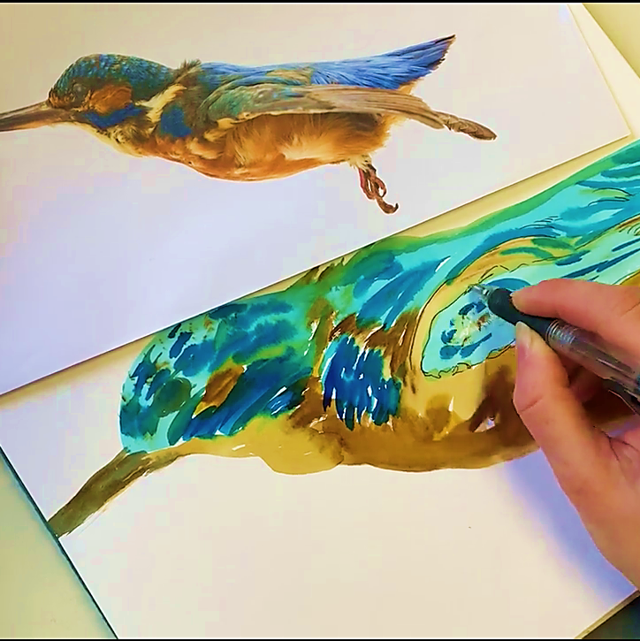
For the kingfisher, Stevie first drew a light pencil sketch of its basic shape before creating a colourful background with watercolours. After leaving this to dry, she worked in details using a simple biro. Finally, she added cream acrylic paint on the eye and end part of some feathers to highlight them. See how you can experiment with different mediums to capture a bird’s colours and textures!

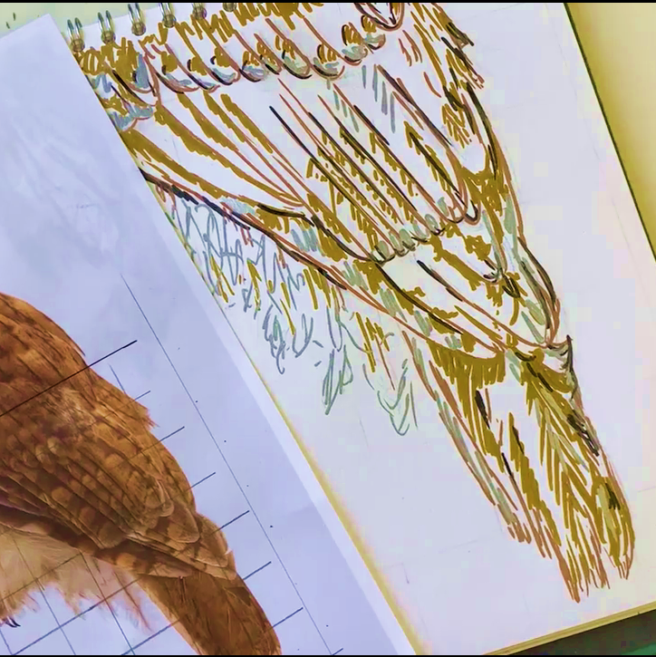
Once Stevie completed her pencil sketch, she added colour and detail using her metallic felt tip pens. She does this in a very relaxed way, building lots of lines, to create a more abstract or stylised version of the original image. Have a go at focusing on the little details, like the direction of the feathers or the different layers of colours.

