Audience: suitable for children aged 5+
This activity is great for: learning more about subjects that interest you, inspiring creativity through storytelling and sharing with friends and family.
How long will it take to make? At least 15 minutes but can be longer depending on how detailed your game is.
Introduction: board games have been played since civilisation began - they were important enough in Ancient Egyptian culture that some people were even buried with them! Derby Museums has a range of gaming items in its collection, from Roman counters, to 1940s board games. Some games, like chess and backgammon, require complex rules, but here you can learn how to create a traditional ‘Race-to-the-End’ game, inspired by our collections. Share and explore themes you enjoy with friends and family by playing a board game you’ve created!
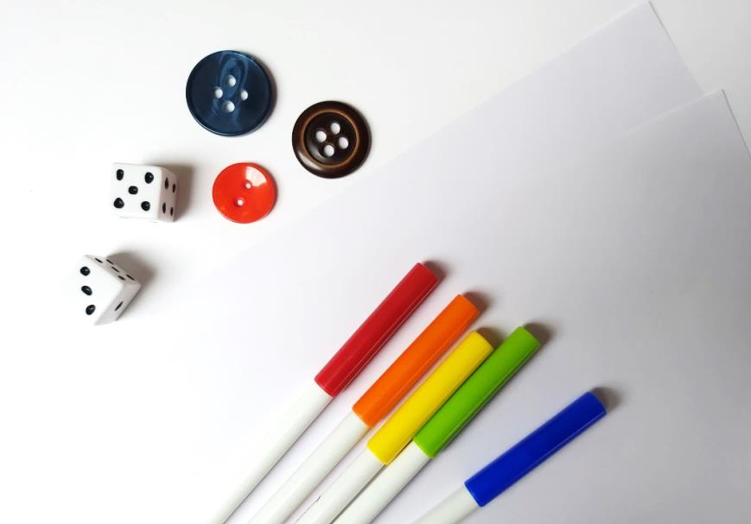
You will need:
- Blank paper or card for your board
- Drawing materials – pens, pencils, crayons etc.
- Dice – you can use our template if you don’t have your own
- Materials for counters, e.g. Buttons, coins, card or playdough
- Glue or tape (optional)
- Scissors (optional)
- Decorative items - stickers, sequins, beads etc. (optional)

Share your creations using #MakeYourMonday
What to do:
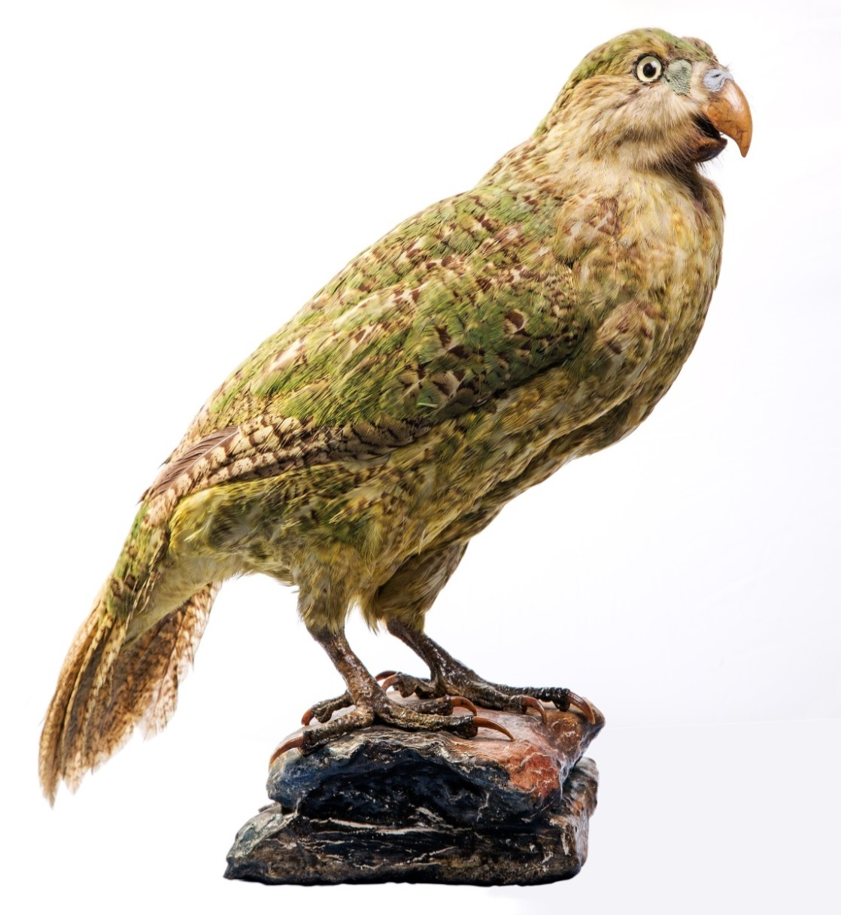
Step 1
Choose a theme for your game. This can be whatever you like, such as space, summer or dragons. You could be inspired by the Derby Museums’ collections, like discovering an Egyptian mummy, discovering a Nature Gallery animal, or a log boat race!

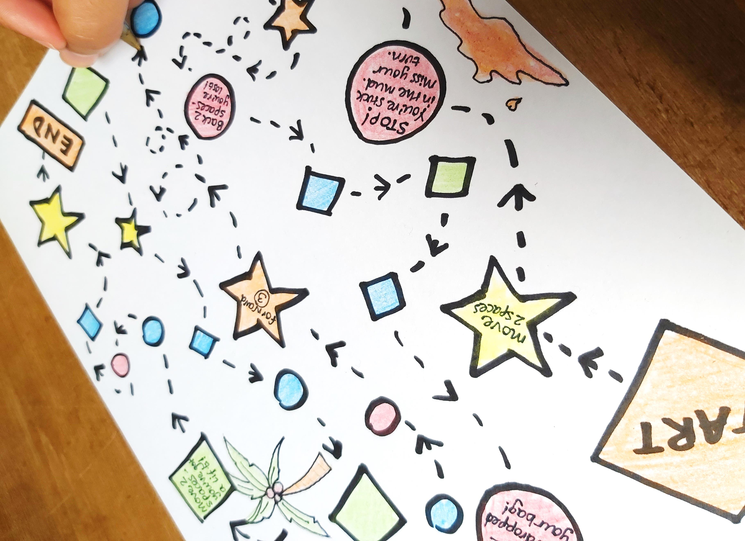
Step 2
Design a board (or use one of our templates).
Plan rewards and challenges for some of your spaces, for example:
- Discover secret entrance, go forward 3
- Hit by meteor, go back 2
- Fall into a mud pool, miss a turn to have a bath
Leave most of the squares on the board blank, adding enough rewards and challenges to keep things interesting, but not enough to make it too easy or hard to win!

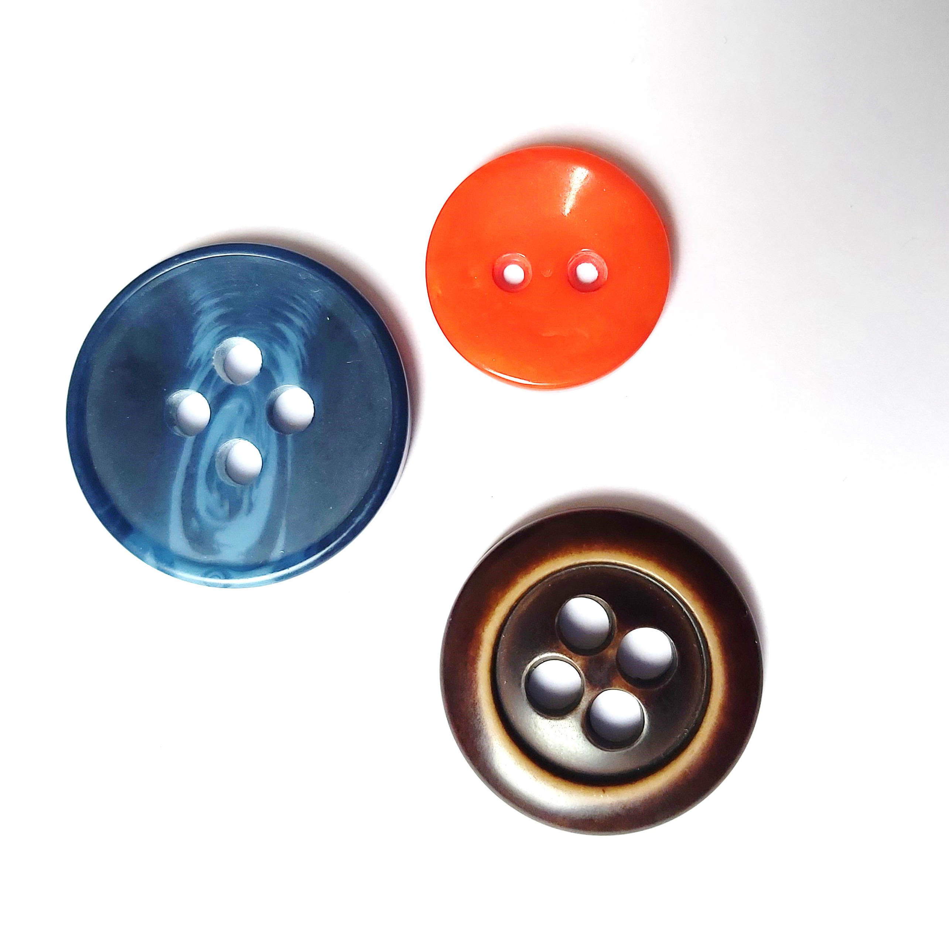
Step 3
Get a die and collect / make your counters (you can use the templates below). Now you can start a game!
You might want to try…
- Making some of the spaces on your board a task, like doing star jumps, or racing to find an object
- Creating your own version of other board games, such as a strategy game

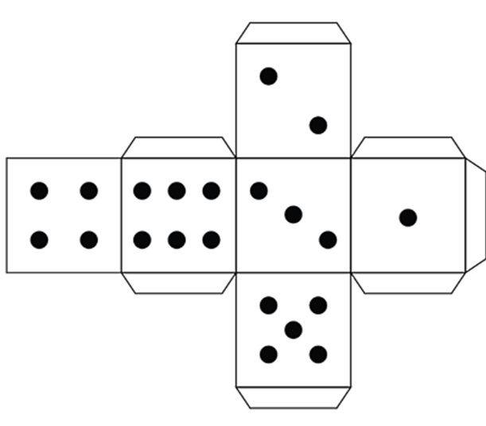
Die, counter and game space templates:

Board templates:

V

