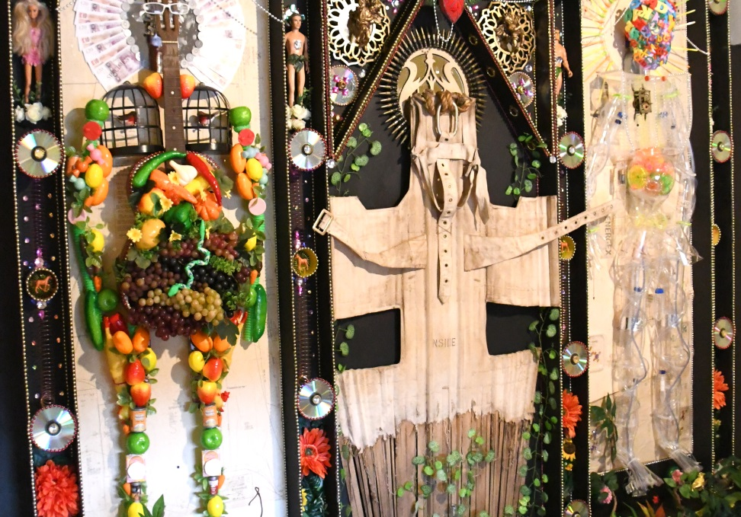**Audience:**

This activity is for families and is particularly suitable for SEND children.

**Introduction:**

Make a body sculpture inspired by the artist Tan Draig, whose artwork ‘Altar to Health’ is on display at Pickford’s House. In his artwork, Tan uses all sorts of different objects to create a body sculpture. One of the bodies is made up of food, which is a way of thinking about how ‘we are what we eat’!

You can watch a short video about this artwork on **derbymuseumsfromhome.com**

Go on a treasure hunt around your home to find different objects that you can use to build your own body sculpture!

**You will need:**

Use whatever you can find around the house. Here are some ideas…

* Stationary – pens, pencils, rulers, rubbers, sharpeners
* Recyclables – plastic bottles, old envelopes, toilet roll tubes
* Toys – Lego bricks, character figures, cars, balls
* Utensils and tools – cutlery, mugs and cups, keys

**Step 1**

Gather your objects together to start thinking about how they could form your sculpture. Think about the meaning behind the objects and how they could represent different things about your body.



**Step 2**

Find a plain background to begin laying your sculpture out. If your sculpture is very big you might want to use a sheet, but if it is smaller you can use plain paper. You might want to focus on one part of the body, like an arm or a face.



**Step 3**

Experiment with different layouts. The great thing about this sculpting technique is that you can keep moving things around! When you’re happy with your sculpture, you can take a picture to keep a record of your creation.



You can share your body sculptures with us online using **#MakeYourMonday**