Audience: suitable for children aged 5+ with their grown-ups.
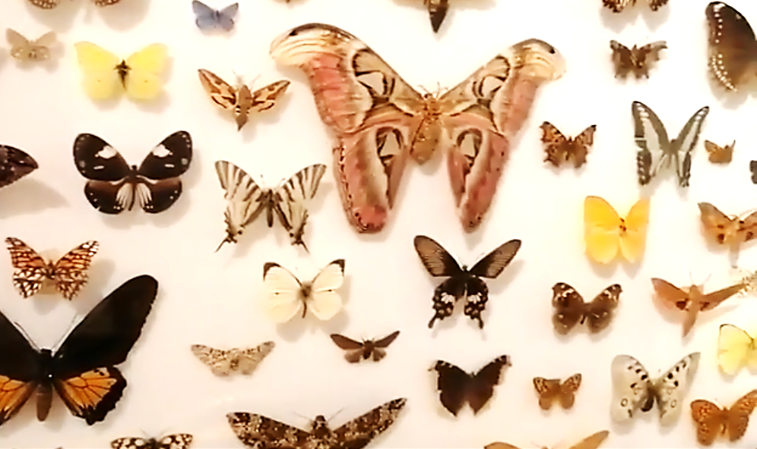
Introduction: Be inspired by the butterflies in our Notice Nature Feel Joy gallery and make your own brightly coloured creations. Put your butterflies into pot plants, on a mobile, make a mask - anywhere that needs brightening up!
Butterflies come in three designs:
- Warning colours like red, white, black and yellow to symbolise danger. The red admiral is an example of a butterfly with this type of design.
- Large eyes on the wings like with the peacock butterfly, which scare predators.
- Camouflaged with greens and browns, like the speckled wood butterfly.

To make your own, you will need:
- Blank paper
- Drawing materials – paint, pens, pencils, brushes etc.
- Scissors
- Glue or tape
- Straws, craft sticks or pipe cleaners
- Decorative items - beads, tissue paper, sequins (optional)

Here are some of the fascinating butterflies on display in Derby Museums’ Notice Nature Feel Joy Gallery.
Share your butterflies using #MakeYourMonday
What to do:
Step 1
Fold your piece of paper or card in half and then draw half the butterfly’s head, body and tail and two wings. Cut this shape out. When you unfold the paper you should have a symmetrical butterfly.
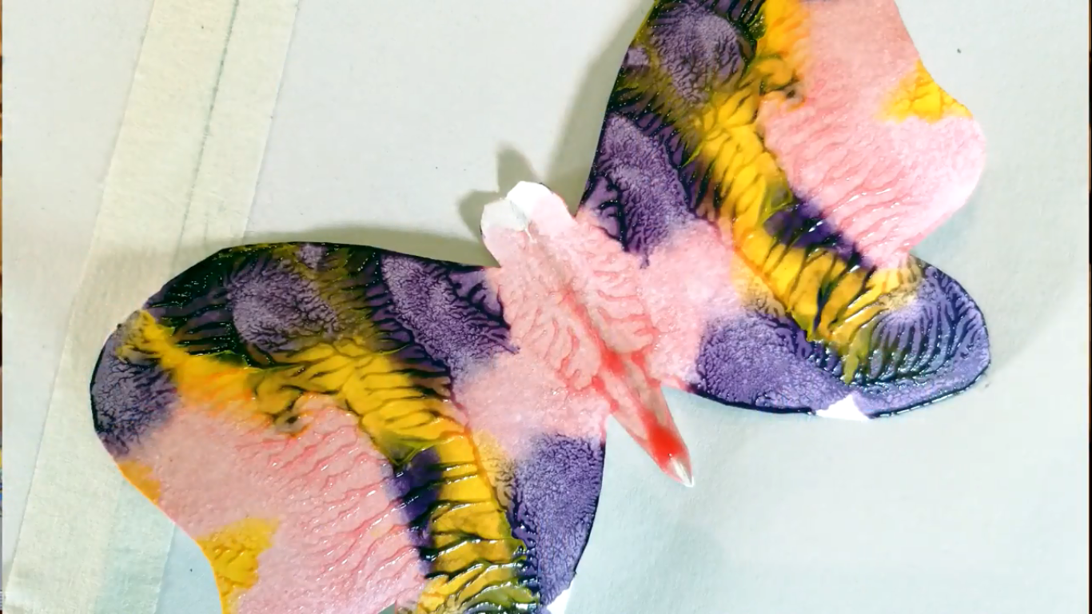
Step 2
If you are using paint, decorate one half of your butterfly and then fold it so that the paint will transfer to the other side, creating a symmetrical design. If you are using pens or pencils, you can try and make the design symmetrical by using a mirror. Add sequins and beads to make your butterfly extra eye catching!

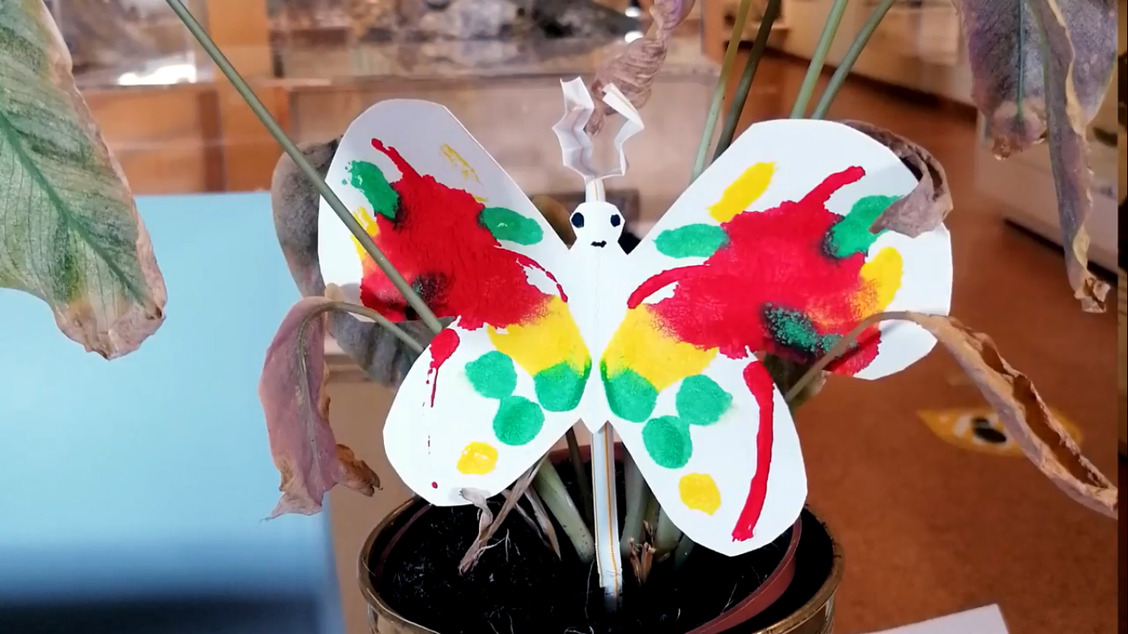
Step 3
Make some antennae using the left over card or paper and use glue or tape to stick them to the top of your straw, pipe cleaner or craft stick. Once these are secured, attach your butterfly. It’s now ready to add to your plant pot to brighten it up!

