Audience: Suitable for children aged 5+ with their grown-ups.
This activity is great for: building relationships and being creative.
How long will it take to make? About 15 minutes, but can take longer depending on how detailed you would like to be!
Introduction: You may have noticed that some leaves are formed in the shape of a heart. One example is a plant known as siliphium, which was used in the Greek and Roman eras and had heart shaped seed pods, and this may have started the tradition of using this shape to express love. In our World Collection Gallery, we have a wonderful example of nature being represented in art with this brass box, which may represent the betel leaf. In this Make, we’ll show you how to create a thoughtful card for your loved ones by combining the heart and leaf shape in an eye catching design.
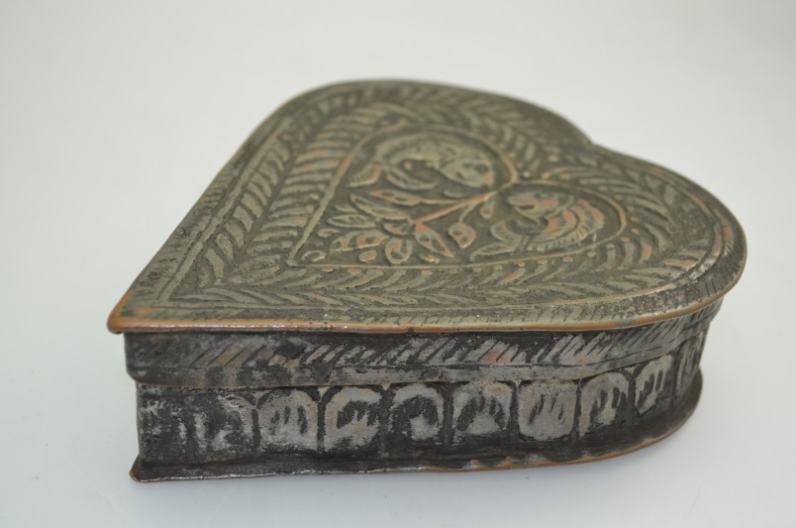
You will need:
Kashmir, India/Pakistan, Asia.
19th – early 20th Century.
- An A4 piece of white paper or card
- Red paper or card
- Brown and green paint
- Paint brushes
- Scissors and glue
- Lolly pop sticks / coffee stirrers or clean twigs

Step 1
Fold your piece of paper or card in half.
Then, take a lolly stick and carefully paint one long edge of it brown. Press the painted edge onto the middle of your piece of paper to form the trunk of your tree.
Repeat this process using lolly pop sticks of different lengths to form the branches.

Step 2
Next, take a clean stick and dip the short edge in some green paint. Use this to create some leaves and buds on your tree.
You can also add some buds at the bottom of your tree by sweeping your lolly stick in small, upward strokes. These could be spring flowers like daffodils or snowdrops!

Step 3
Cut some hearts out of the red paper. You can do this by cutting a small square, folding it in half, and then drawing half the heart shape – this will make it symmetrical.
Make a heart for each of your loved ones (this could be your family, your friends, or even your pets) and personalise it by writing their initial, then glue onto the tree.

